How To Use FactoryTalk SE ActiveX Control Setup
For Use with FactoryTalk SE 6.0 or 7.0

Welcher, Michael S
7/8/2016

A quick description of the how to create a cab file using CABARC is that you always should make your files first, meaning make the cab file and the .ocx or .dll then run the simpctrl.inf to fill the files with the proper information.
The three type of files used in this process are simpctrldll.cab, simpctrl.inf, simpctrl.dll or if the you are using a ocx then simpctrlocx.cab, simpctrl.inf, simpctrl.ocx
These are all done using the cmd.exe as shown in this document.
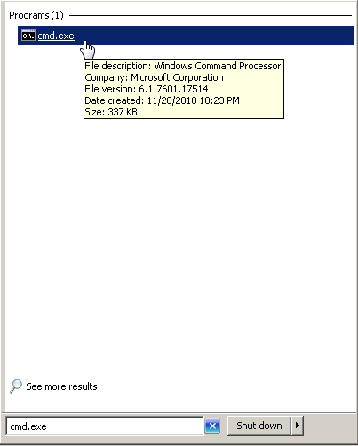
Press Windows Start menu then type in cmd.exe in the search programs and files box as shown above then open it.
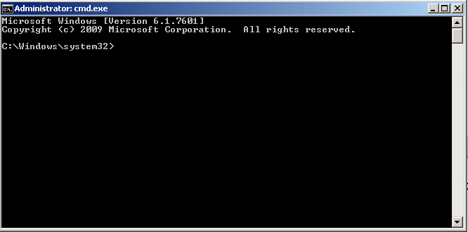
The command prompt should open then type in cd C:\Users\Public\Documents\RSView Enterprise\ActiveX Control Setup then press enter.

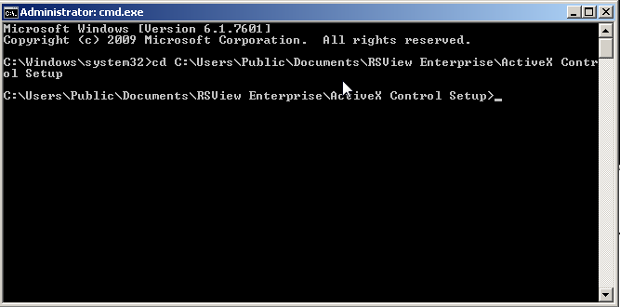
Now the command prompt should be pointing to C:\Users\Public\Documents\RSView Enterprise\ActiveX Control Setup as shown above.

Leave the command prompt open then search out that location and open the ActiveX Control Setup folder.

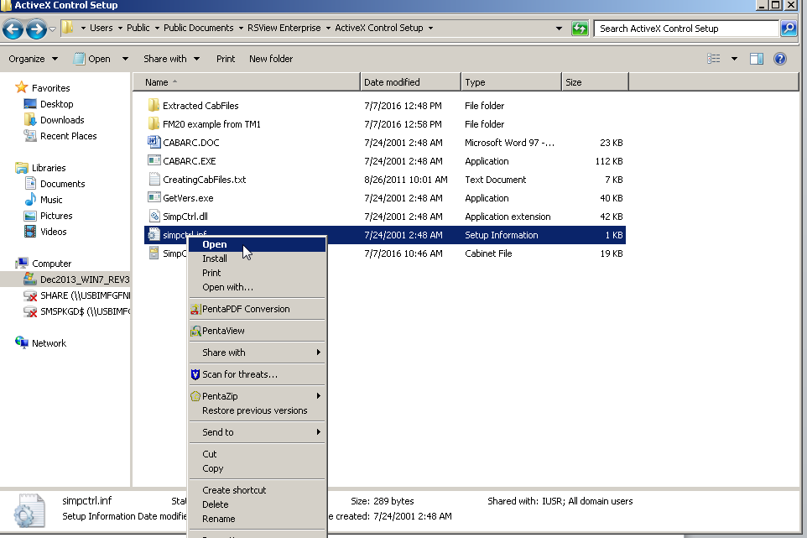
In file location C:\Users\Public\Documents\RSView Enterprise\ActiveX Control Setup Open simpctrl.inf as shown above.
This screen will appear.
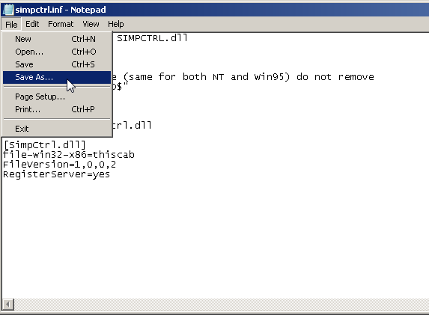
Press file and save as
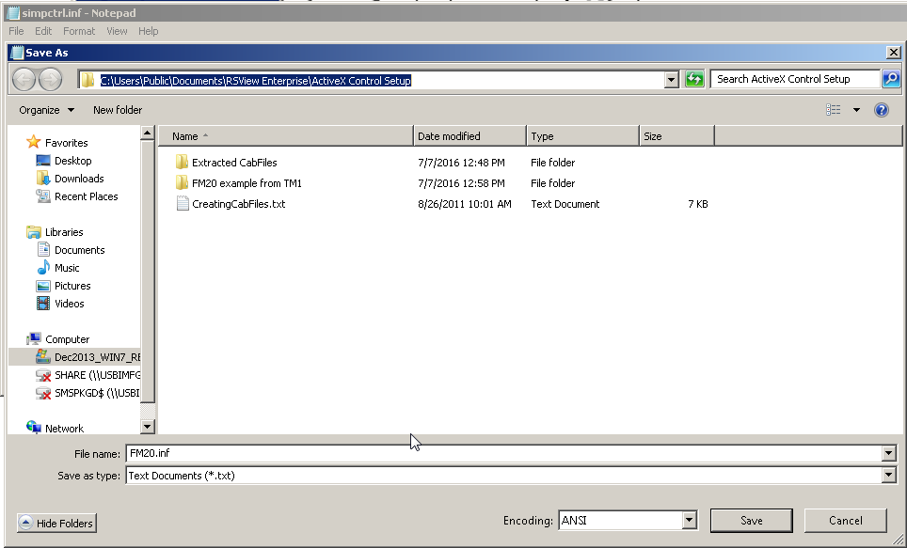
Name the save as file FM20.inf in the same file location then press save.
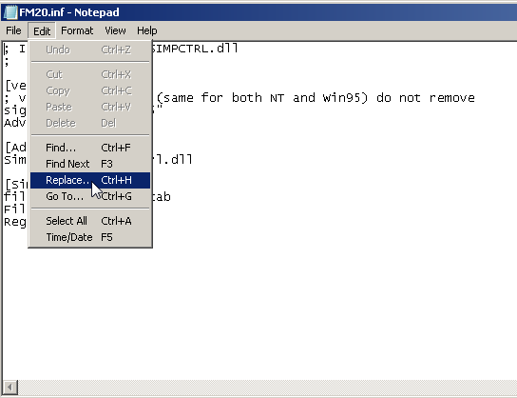
Edit then Replace
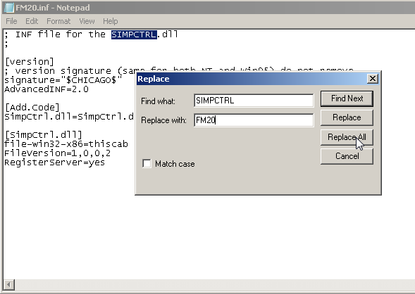
In the Find what: location enter simpctrl
In the Replace with: enter FM20
Press Replace all.
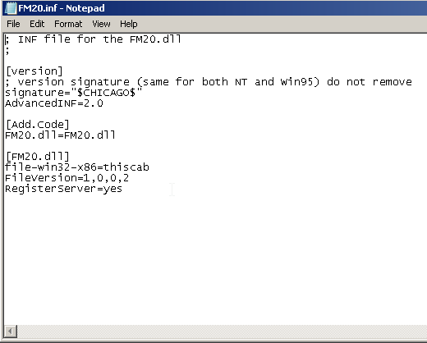
The text should look as so now.
Press save and close
Open CMD prompt and type in cd C:\Users\Public\Documents\RSView Enterprise\ActiveX Control Setup
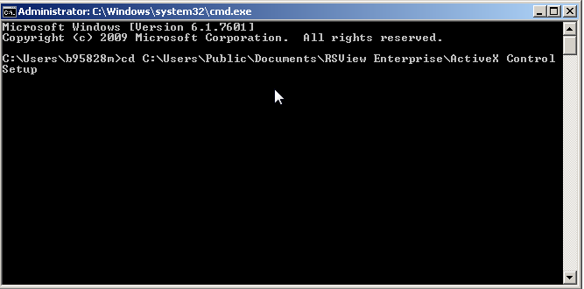
Then press enter
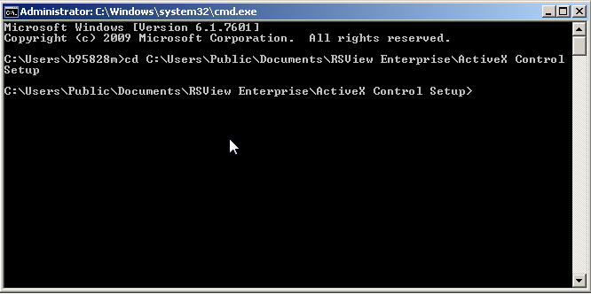
This points the CMD directly at the C:\Users\Public\Documents\RSView Enterprise\ActiveX Control
Explanation of this command:
CABARC is an exe in the file location and the letter N stands from make a new file.
Type CABARC N FM20Dll.Cab in the cmd and press enter.
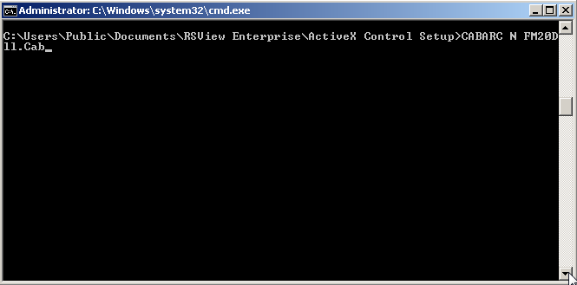
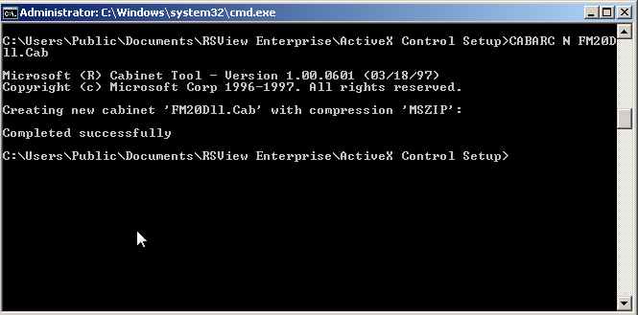
It should indicate that it was completed successfully as shown above.

Now type in CABARC N FM20.dll into the cmd and press enter.
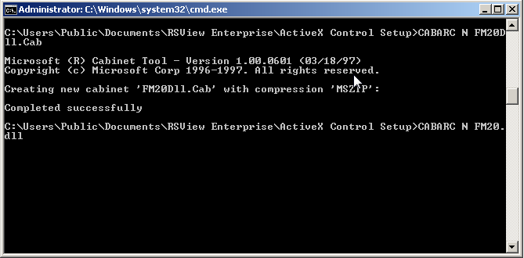
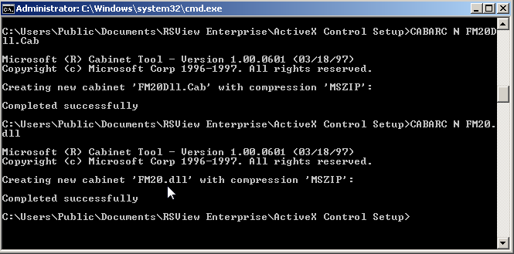
It should indicate that it was completed successfully then Type in CABARC N FM20Dll.Cab FM20.inf FM20.dll as shown below then press enter.
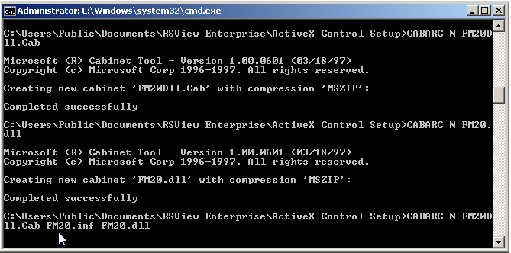
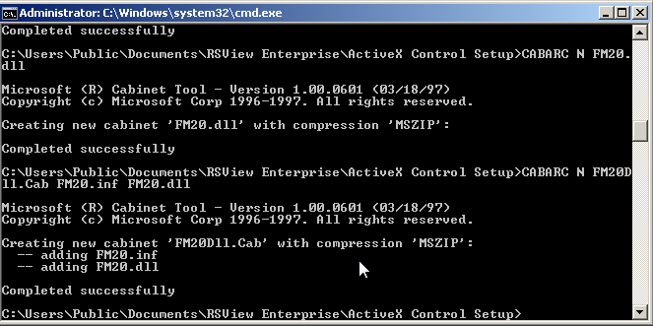
It should indicate that they have been created and show that they were added.
Now go back to the file location C:\Users\Public\Documents\RSView Enterprise\ActiveX Control Setup and view that the files were made in the proper location
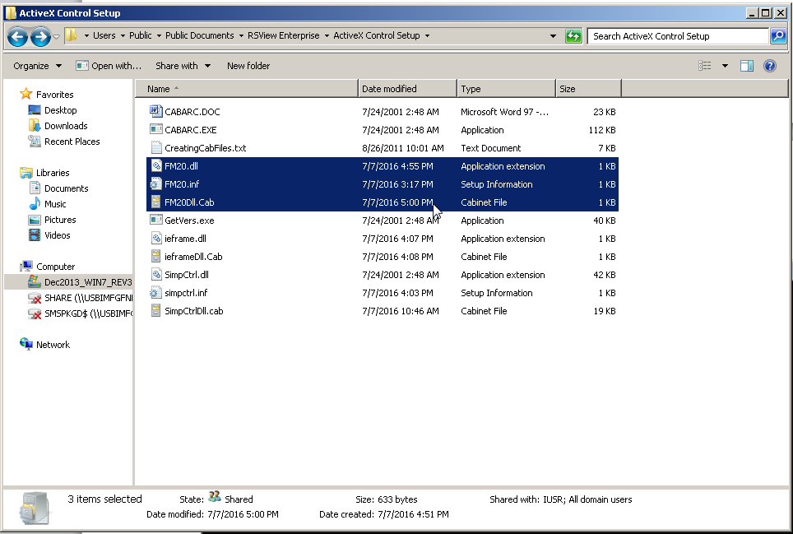
You can open the cab file to verify that it did get filled with data as shown below. Note: do not edit the cab file.
